5 Major Causes of Industrial Fires and Explosions

Industrial fires and explosions cost companies and governments billions of dollars every year, not to mention the loss of life, which can’t be described in monetary terms.

According to the most [recent fire statistics](http://www.nfpa.org/news-and-research/fire-statistics-and-reports/fire-statistics/fires-by-property-type/industrial-and-manufacturing-facilities/fires-in-us-industrial-and-manufacturing-facilities) from the National Fire Protection Association (NFPA):

* An average of 37,000 fires occur at industrial and manufacturing properties every year.
* These incidents result in:
  + 18 civilian deaths,
  + 279 civilian injuries, and
  + $1 billion in direct property damage.

These disasters happen for many reasons, often because managers and employees aren’t aware of the risks that surround them at work every day.

Here are five of the most common causes of industrial fires and explosions.

## **1. Combustible dust**

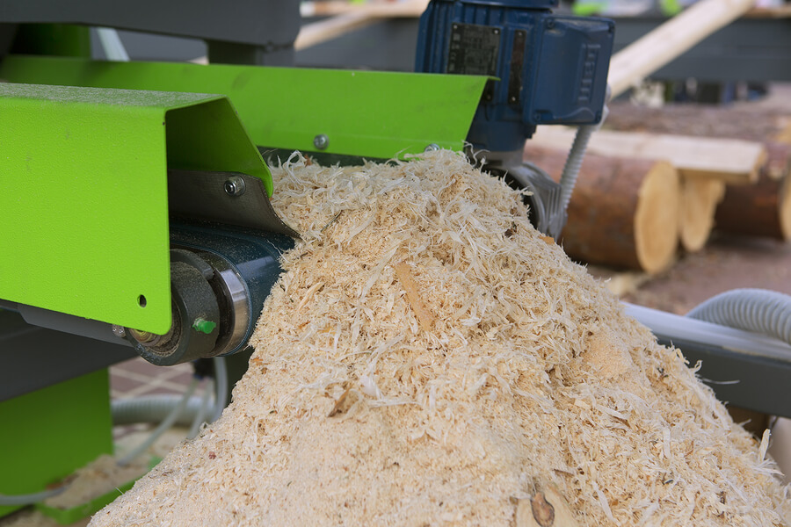

Often overlooked, and highly deadly, combustible dust is a major cause of fire in [food manufacturing](https://news.nilfiskcfm.com/2016/04/food-manufacturers-guide-fire-prevention-housekeeping-nfpa-codes-standards-need-know/), woodworking, chemical manufacturing, metalworking, pharmaceuticals, and just about every other industry you can name. The reason is that just about everything, including food, dyes, chemicals, and metals — even materials that aren’t fire risks in larger pieces — has the potential to be combustible in dust form.

And these explosions aren’t easy to contain. In the typical incident, a small fire will result from combustible material coming into contact with an ignition source. This may be a dust explosion, but it doesn’t have to be. In fact, it could be most any other type of explosion on this list.

However, this small explosion isn’t the problem. The problem is what happens next. If there’s dust in the area, the primary explosion will cause that dust to become airborne. Then, the dust cloud itself can ignite, causing a secondary explosion that can be many times the size and severity of the primary explosion. If enough dust has accumulated, these secondary explosions have the potential to bring down entire facilities, causing immense damage and fatalities.

Just recently, [OSHA fined a manufacturing company nearly $150,000](http://ehstoday.com/osha/osha-cites-georgia-manufacturer-after-worker-injured-flash-fire) after a worker was injured while operating a dust collector. It was the company’s fourth fire in a dust collection system, and inspectors cited them for knowingly exposing workers to risk.

### **How to prevent combustible dust incidents**

The key ingredient in combustible dust fires and explosions is the presence of the dust itself. While you probably won’t be able to eliminate dust entirely, you can make sure it doesn’t accumulate to a dangerous level simply by following a regular housekeeping regimen.

Last November, one of our resident experts on the topic, participated in a podcast on avoiding combustible dust hazards and contamination. Read more in this three-part article series:

* [Part 1: What is Going on with Combustible Dust?](https://news.nilfiskcfm.com/2015/11/avoid-combustible-dust-hazards-contamination-series-part-1/)
* [Part 2: How Can Companies Prevent Combustible Dust Risks?](https://news.nilfiskcfm.com/2015/11/avoid-combustible-dust-hazards-contamination-series-part-2/)
* [Part 3: What Does Nilfisk Specifically Do for Its Customers?](https://news.nilfiskcfm.com/2015/12/avoid-combustible-dust-hazards-contamination-series-part-3/)

Also, check out [this video on how you can take more action to prevent combustible dust explosions](https://news.nilfiskcfm.com/2010/07/take-more-action-to-prevent-combustible-dust-explosions/) and visit the [section of our blog devoted to combustible dust](https://news.nilfiskcfm.com/category/combustible-dust/) for more information about this common and deadly risk.

To dig into the details, explore the brand new [NFPA 652: Standard on the Fundamentals of Combustible Dust](http://www.nfpa.org/codes-and-standards/all-codes-and-standards/list-of-codes-and-standards?mode=code&code=652).

## **2. Hot work**

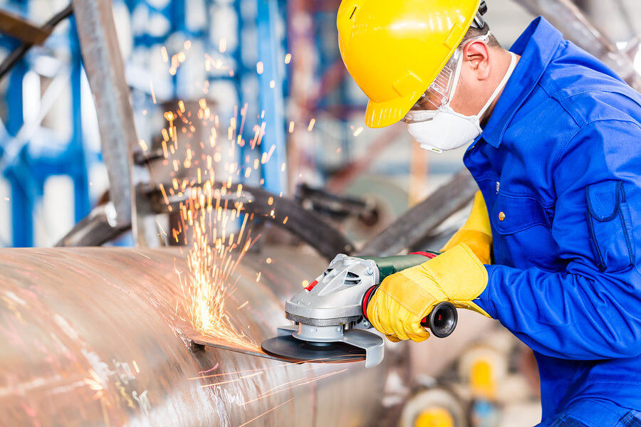

Hot work is one of the leading causes of industrial fires across all industries.

Although hot work is commonly equated with welding and torch cutting, there are many other activities — including brazing, burning, heating, and soldering — that pose a fire hazard. This is because the sparks and molten material, which reach temperatures greater than 1000°F, can [easily travel more than 35 feet](https://ohsonline.com/Articles/2009/04/01/Controlling-Hot-Work-Fire-Hazards.aspx?Page=1).

Here are a few recent catastrophes that were the result of hot work:

* In 2014, [a pier fire in California did more than $100 million in damage](http://www.nfpa.org/news-and-research/publications/nfpa-journal/2015/november-december-2015/features/large-loss-fires-2014) when it caused a partial collapse of a warehouse floor.
* In 2012, [three workers performing hot work died disassembling a metal crude oil tank](http://www.hgi-fire.com/blog/fatal-hot-work-accident-kills-three). The sparks from the work ignited vapors inside the tank, causing a fire that then spread to nearby woods.
* In 2010, [one worker died and one was injured in an explosion](http://www.csb.gov/e-i-dupont-de-nemours-co-fatal-hotwork-explosion/) while performing welding on a 10,000 gallon slurry tank. Similar to the previous incident, the sparks from the welding ignited vapors inside the tank.

Hot work is also a major culprit in combustible dust fires, as the sparks generated from the work can ignite dust in the surrounding area.

In [one accident in North Carolina](http://digital.ncdcr.gov/cdm/ref/collection/p249901coll22/id/12071), three contract welders were seriously burned when sparks ignited the wood dust in the silo where they were working. The investigation found a trifecta of problems: the silo hadn’t been cleaned of dust before the work began, no hot work permit had been issued, and there was no fire protection and prevention plan in place.

### **How to prevent hot work incidents**

Like combustible dust incidents, hot work disasters are preventable by following proper safety procedures.

* **Avoid hot work if possible.** This isn’t always a feasible solution, but if there’s an alternative, take it.
* **Train personnel** on the hazards associated with hot work, any site-specific hazards, the proper policies and procedures, and the use of safety equipment.
* **Ensure that the area is clear of flammable or combustible materials** including dusts, liquids, and gasses.
* **Use a written permit system** for all hot work projects, even where permits aren’t required. Better safe than sorry!
* **Supervise the work**. Especially if you use outside contractors, make sure a safety professional is on hand to provide supervision.

Here are some resources where you can learn more:

* *U.S. Chemical Safety and Hazard Investigation Board*. [Dangers of Hot Work [YouTube Video]](https://www.youtube.com/watch?v=zWkcuR0adeI)
* *Occupational Health & Safety*. [Controlling Hot Work Fire Hazards [Article]](https://ohsonline.com/Articles/2009/04/01/Controlling-Hot-Work-Fire-Hazards.aspx?Page=1)
* [NFPA 51B: Standard for Fire Prevention During Welding, Cutting, and Other Hot Work [Standard]](http://www.nfpa.org/codes-and-standards/all-codes-and-standards/list-of-codes-and-standards?mode=code&code=51b)

## **3. Flammable liquids and gasses**

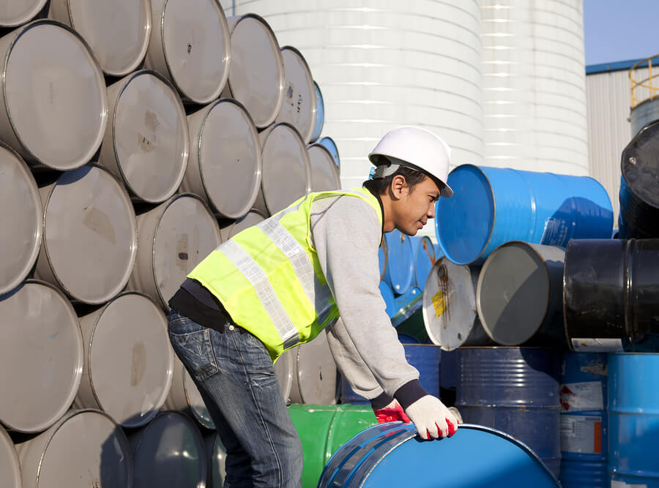

These fires, which often occur at chemical plants, can be disastrous. To see what these look like, check out [this post at Industry Tap](http://www.industrytap.com/5-chemical-plant-explosions-and-what-caused-them/16655). It features videos from five chemical plant explosions that were the result of explosions of flammable materials, such as rocket fuel (which produces a flammable gas), acrylic acid, and crude oil.

The [2010 power plant explosion in Middletown, CT](https://en.wikipedia.org/wiki/2010_Connecticut_power_plant_explosion), which killed six people and injured more than 50, can also be traced to flammable gas. In this case, the subsequent investigation revealed hundreds of safety violations, many of which OSHA deemed “willful.” As a result, [the agency fined the companies involved $16.6 million](http://www.nytimes.com/2010/08/06/nyregion/06middletown.html?_r=0), one of the largest penalties ever issued.

### **How to prevent flammable liquid and gas incidents**

There is certainly some danger inherent in any work involving flammable liquids and gasses, but all available safety precautions should be taken to mitigate these risks.

* **Know the hazards.** One major component of prevention is simply knowing the safety information for every liquid on your premises. This information is available on the material safety data sheet (MSDS) that comes with such products.
* **Store flammable liquids properly.** Make sure all hazardous materials are stored according to OSHA-compliant procedures.
* **Control all ignition sources.** Except for when you’re intentionally heating the flammable materials, keep ignition sources as far away from them as possible.
* **Provide personal protective equipment.** This is a must across all categories of fire hazards but especially when liquids and gasses are involved.

These resources from the U.S. and Canadian federal governments provide more information about how to stay safe and compliant:

* *OSHA*. [Safety and Health Regulations for Construction: Fire Protection and Prevention — Flammable Liquids [Standard]](https://www.osha.gov/pls/oshaweb/owadisp.show_document?p_id=10673&p_table=STANDARDS)
* *Canadian Centre for Occupational Health and Safety.*[*How Do I Work Safely with Flammable and Combustible Liquids [Q&A]*](https://www.ccohs.ca/oshanswers/prevention/flammable_general.html)

## **4. Equipment and machinery**

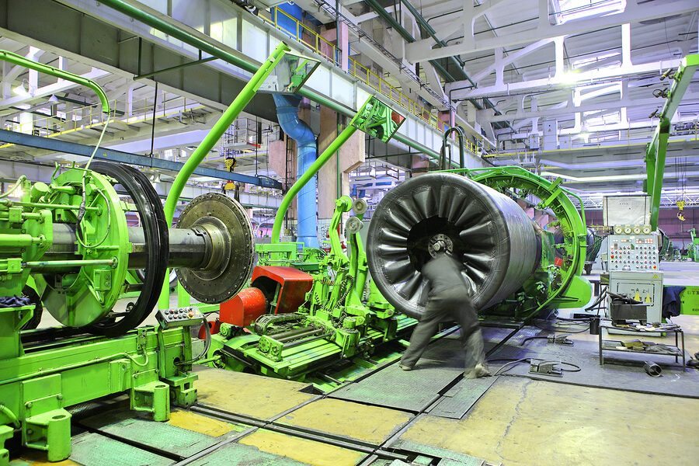

Faulty equipment and machinery are also major causes of industrial fires.

Heating and hot work equipment are typically the biggest problems here — in particular, furnaces that aren’t properly installed, operated, and maintained. In addition, any mechanical equipment can become a fire hazard because of friction between the moving parts. This risk can be brought down to practically zero simply by following recommended cleaning and maintenance procedures, including lubrication.

What may surprise you is that even seemingly innocuous equipment can be a hazard under the right circumstances. And, in many cases, the equipment least likely to be thought of as a fire risk turns out to be the biggest problem. This is because companies may not recognize the risk and therefore won’t take the necessary precautions.

As an extreme example, consider this story from William Fries, a former director at Liberty Mutual Group:

*An electric eraser used by drafters at one company was stored in such a way that the nose of the eraser pressed against the side of the drawer. The contact caused the eraser to switch on and vibrate. The constant friction caused the eraser to overheat and start a fire which spread throughout the room, fueled by the stacks of papers and plans used by the drafters. (*[*source: EHSToday*](http://ehstoday.com/news/ehs_imp_32825)*)*

The lesson here is that when thinking about the safety of your plant, don’t forget about everyday equipment like electric erasers…and coffee makers.

### **How to prevent equipment and machinery incidents**

Strategies for preventing fires due to equipment and machinery issues fall into three main categories:

* Awareness
* Cleaning and housekeeping
* Maintenance

#### **Awareness**

You can’t prevent risks you don’t know exist. Neither can your employees. Provide safety awareness training so everyone in your facility knows what risks to watch out for and what to do if they find one.

#### **Cleaning and housekeeping**

Keep your equipment and machinery — and the area surrounding it — clean. Equipment, especially electrical equipment, that is covered with dirt or grease constitutes a huge risk. By keeping your equipment and machinery clean, you’ll up your chances that, should a fire start, it won’t have enough fuel available to burn for long.

#### **Maintenance**

Finally, follow the manufacturer’s recommended maintenance procedures for all of the equipment and machinery in your plant. In addition to reducing your fire risk by preventing overheating, regular maintenance will also keep your equipment working in tip-top shape.

To separate fact from fiction when it comes to fire risks, check out *Control Engineering’s* [10 Myths About Industrial Fire Prevention](http://www.controleng.com/single-article/10-myths-about-industrial-fire-protection/b9f6bdcf2bee5a7d793af899731e71ef.html).

## **5. Electrical hazards**

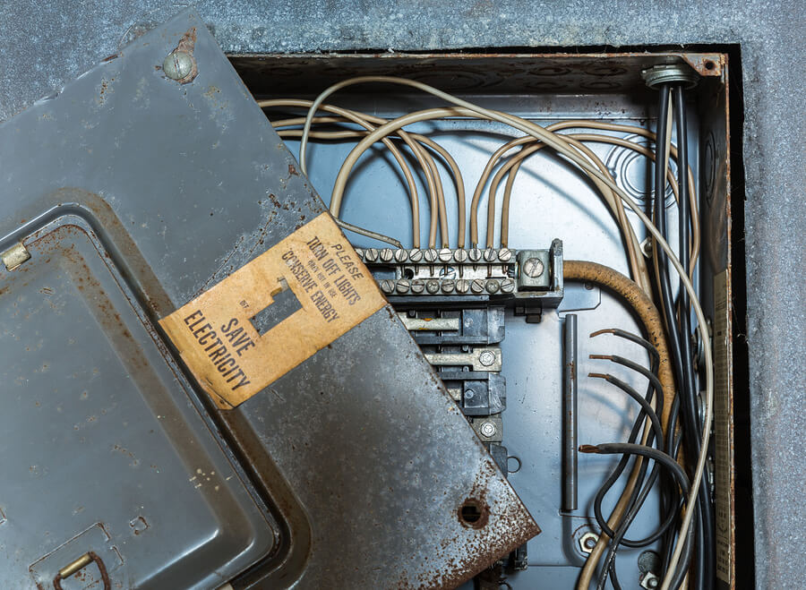

Electrical fires are one of the top five causes of fires in manufacturing plants. Here a non-exhaustive list of specific electrical hazards:

* Wiring that is exposed or not up to code
* Overloaded outlets
* Extension cords
* Overloaded circuits
* Static discharge

The damage caused by these fires can quickly compound thanks to several of the other items on this list. Any of the above hazards can cause a spark, which can serve as an ignition source for combustible dust, as well as flammable liquids and gasses.

### **How to prevent electrical fire incidents**

As with the previous risks, the key to preventing electrical fires is awareness and prevention. This involves training, maintenance, and following best practices. Here are a few to put into practice right now:

* Don’t overload electrical equipment or circuits.
* Don’t leave temporary equipment plugged in when it’s not in use.
* Avoid using extension cords, and never consider them permanent solutions.
* Use antistatic equipment where required by NFPA or OSHA.
* Follow a regular housekeeping plan to remove combustible dust and other hazardous materials from areas that contain equipment and machinery.
* Implement a reporting system so that anyone who observes an electrical fire risk can report it without consequences.

For more information on electrical safety, consult [NFPA 70: National Electrical Code](http://www.nfpa.org/codes-and-standards/all-codes-and-standards/list-of-codes-and-standards?mode=code&code=70) and [OSHA’s “Electrical Safety in the Workplace.”](https://www.osha.gov/dte/grant_materials/fy09/sh-18794-09/electrical_safety_manual.pdf)

## **Building fire safety into your daily operations**

This list of hazards is formidable. But don’t let it intimidate you. Fire safety is mostly a matter of establishing policies and procedures, and then ensuring they are implemented throughout your facility.

Here are five ways to build fire safety into your operations from the get-go:

### **Conduct a hazard analysis**

A Dust Hazard Analysis (DHA) is one of the requirements of NFPA 652. But don’t stop at dusts. Conduct a hazard analysis of your entire facility to discover exactly where your greatest risks lie and what you can do to address them. Reanalyze your operations regularly, for example, every time you install a new piece of equipment on your production line.

### **Establish fire prevention and emergency procedures**

Make sure you have policies and procedures in place that cover everything from smoking to personal protective equipment to an emergency evacuation plan. Ensure everyone has access to these documents at all times. For example, you could post them in strategic places in your facility.

### **Provide fire safety training**

We’ve mentioned training several times already. That’s because it’s so important. Provide both general and job-specific fire safety training for everyone working in a potentially hazardous environment.

### **Implement a regular housekeeping routine**

With equipment and machinery running, sometimes 24 hours a day, sparks and static discharge may be hard to avoid entirely. But that doesn’t mean you need to run the risk of a fire or explosion, especially one due to combustible dust. By implementing a regular housekeeping routine, you can significantly decrease the chances of a small spark turning into a huge disaster.

### **Inspect and maintain your equipment and systems**

Keeping all of your equipment and systems in proper working order will enhance safety and make your operations more efficient. This includes maintaining the machinery on your production line as well as inspecting and testing your fire safety systems, like fire extinguishers and sprinklers. A good rule of thumb is to perform inspections every six months.